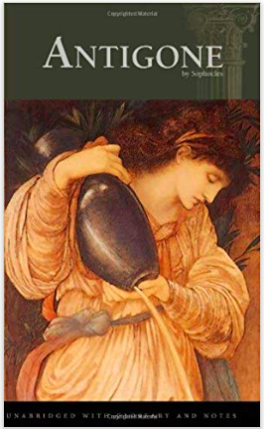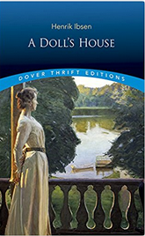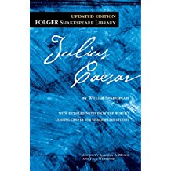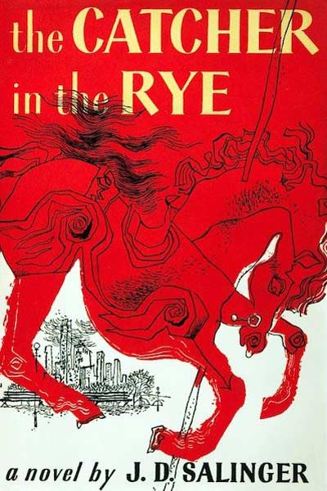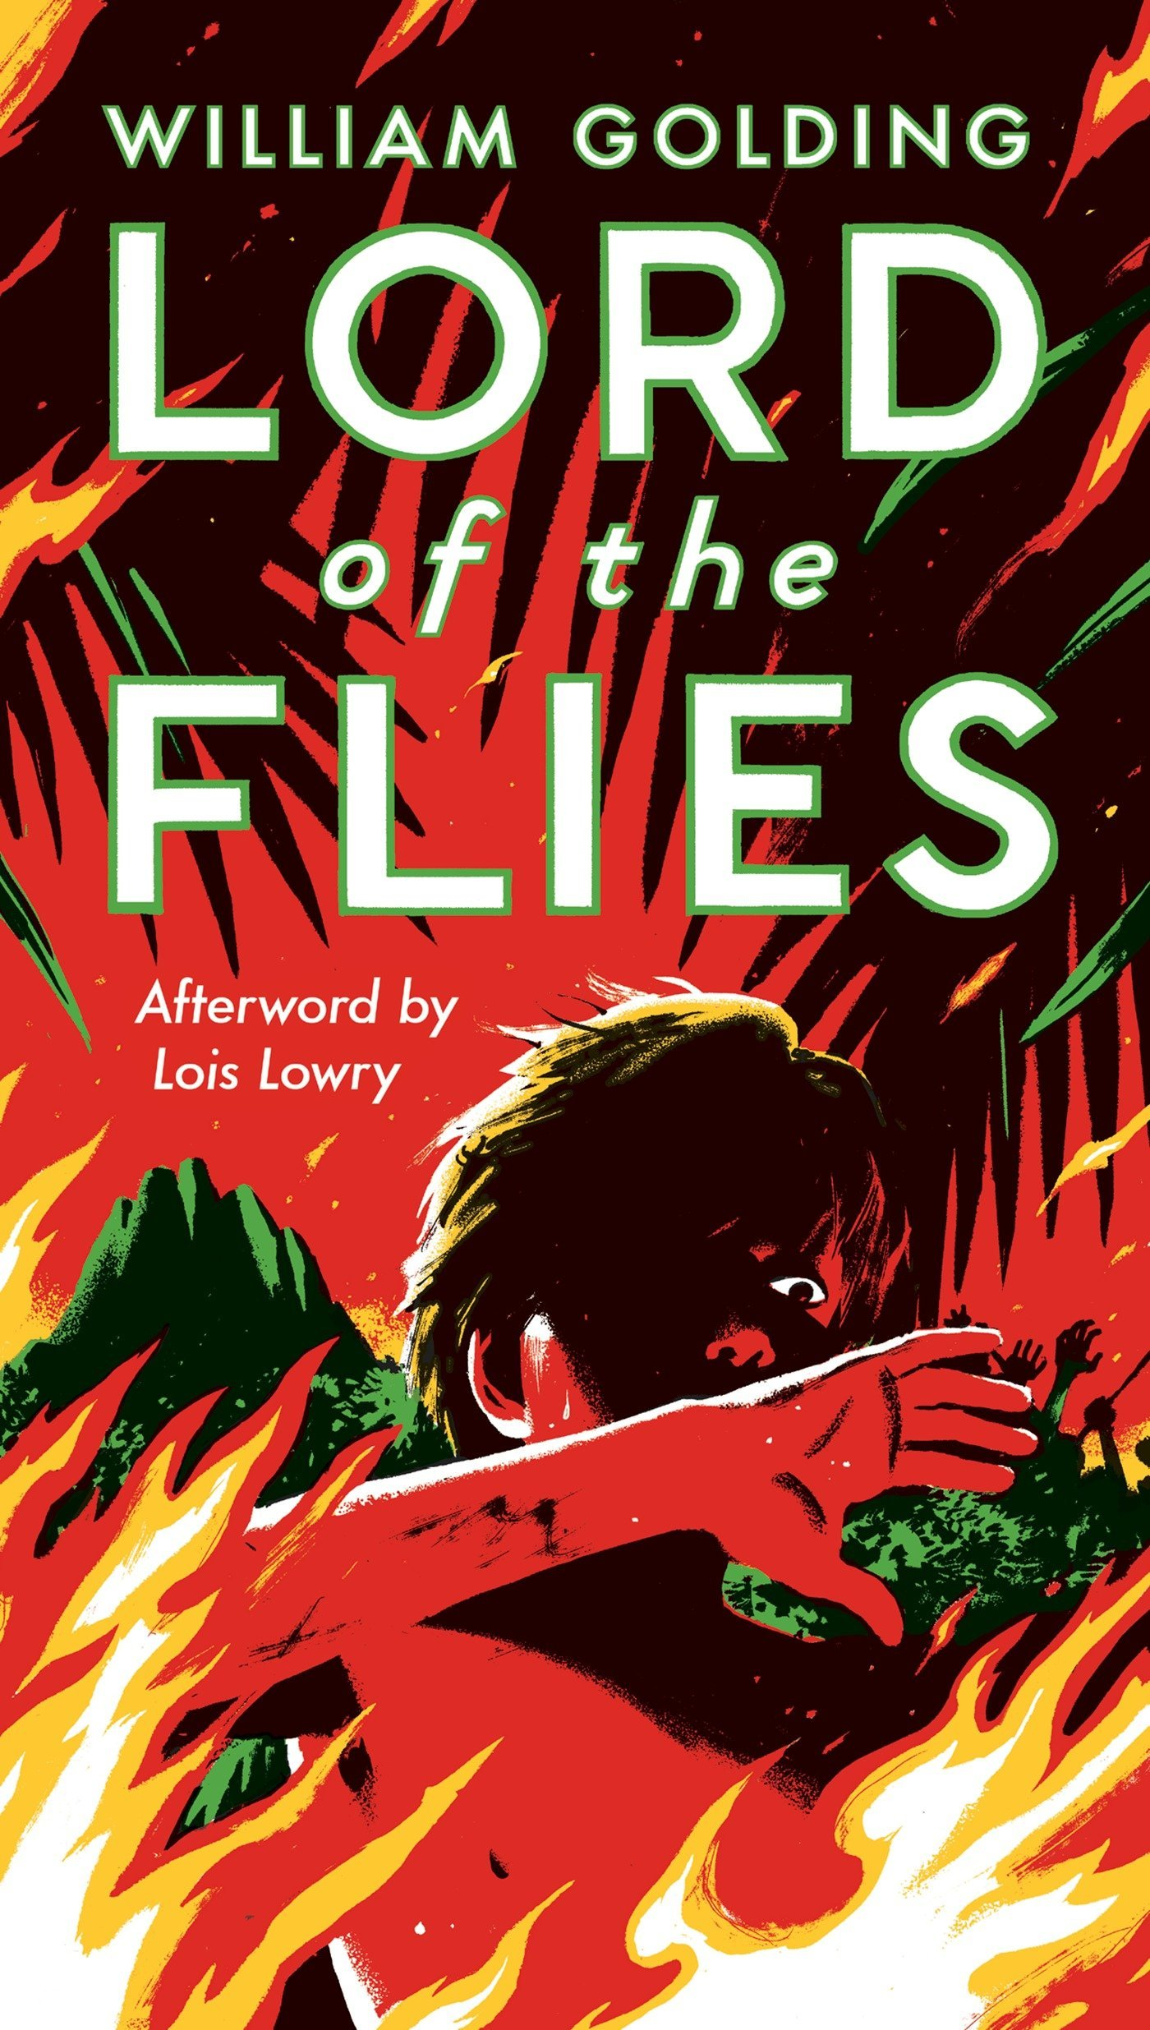

GRADE 10-

EDITION COVERS

*Antigone-* Sophocles

*A Doll’s House-* Henrik Ibsen (Dover Thrift Edition)

*Julius Caesar-* Shakespeare (Folger edition)

*The Catcher in the Rye*- J.D. Salinger

*Lord of the Flies*- William Golding